Optimizing Operations & Building Solutions for Peer Connections

A Project Report

Presented to

The Faculty of the College of Engineering

San José State University

In Partial Fulfillment

Of the Requirements for the Degree

Master of Science in Engineering Management

By

**Akash Adep**

**Aviral Singh**

Advisor:  
Dr. Supreeta Amin   
Dr. Anil Kumar

May 2019

Table of Contents

Background 5

Problem Statement 6

Objectives 7

Methodology 7

Data Collection and Exploration 7

For Tutor and Mentor Usage 7

Data for evaluating the result of working with mentors 8

Data for Supplemental Instruction Sessions 11

RESULTS 11

Tutor Mentor Usage Results 11

Supplemental Instruction Sessions 15

Data Cleaning 16

Evaluation of working with a mentor 22

Recommendations 36

For Objective 1: 36

Goal setting for KPIs: 36

Involving academic staff for all courses tutored by classic tutors: 36

Building a “Holistic Development Program”: 36

For Objective 2: 36

For Objective 3: 37

Concluding Remarks 38

References 39

**List of Figures**

Figure 1 Mentoring Intro and Outro Form (Front Page) 9

Figure 2 Mentoring Intro and Outro Form (Back Page) 10

Figure 3 Line Plot for Tutor Usage from Spring 2016 - 2018 19

Figure 4 Line Plot for Usage from Fall 2016 - Fall 2018 20

Figure 5 Line Plot for Mentor Usage from Spring 2016 - 2018 21

Figure 6 Line Plot for Tutor Usage from Fall 2016 - Fall 2018 22

Figure 7 Response Comparison for Question 1 24

Figure 8 Response Comparison for Question 2 25

Figure 9 Response Comparison for Question 3 26

Figure 10 Response Comparison for Question 3 27

Figure 11 Response Comparison for Question 5 28

Figure 12 Response Comparison for Question 6 29

Figure 13 Response Comparison for Question 7 30

Figure 14 Response Comparison for Question 8 31

Figure 15 Response Comparison for Question 9 32

Figure 16 Response Comparison for Question 10 33

Figure 17 Response Comparison for Question 11 34

Figure 18 Response Comparison for Question 12 35

**List of Tables**

Table 1Tutor Usage Data 12

Table 2 Mentor's Usage Data 13

Table 3 Comparison of Tutors and Mentors data requested, and data provided 14

Table 4 Comparison of SI Data Requested and Data Provided 16

Table 5 Data collected from Intro and Outro forms data format 17

Table 6 Aggregated Tutor Usage 18

Table 7 Aggregated Mentor Usage 18

# Background

[Peer Connections](http://peerconnections.sjsu.edu/) is a campus-wide resource where services such as tutoring, mentoring, and supplemental instruction are offered for students attending San Jose State University. Peer Connections was established during the summer of 2012 by integrating two different programs at San Jose State University, the Learning Assistance Resource Center (LARC) and the Peer Mentor Program. Peer Connections aims to inspire students toward becoming independent learners, assist students in the development of their full academic potential, and to facilitate student success in the fulfillment of San Jose State University's academic and graduation requirements. Peer Connections offers the following three services

##### Mentoring

Peer Mentors are guides to the university experience and support the social and academic adjustments to life at SJSU. Mentors assist students with their study skills, adjusting to life as a college student, getting connected on campus, finding campus resources, and personal issues. Peer Connections currently has a team of 33 Peer Mentors. There are three ways students can schedule a mentoring appointment:

* Online – Students can visit Spartan Connect (it is an online resource provided by SJSU, that connects students to advising, tutoring, mentoring, workshops, and other services) to book appointments with mentors.
* Phone – Students can call Peer Connections welcome desk on regular business hours to schedule an appointment.
* In-person – The welcome desk staff at Peer Connections can book an appointment for the students when they visit in person.

##### Classic and Embedded Tutoring

A team of 40 including Classic and Embedded Tutors have a goal of helping students at SJSU become independent learners. Tutors believe that as independent learners, tutees will be more successful in their classes and in achieving their academic and personal goals. Classic tutors offer appointments and drop in tutoring for a wide variety of subjects as well as undergraduate and graduate student writing. Embedded tutors are assigned to specific course sections and attend every class they are assigned to. Outside of class, they offer tutoring appointments for students in the course. Students can schedule an appointment in similar ways to that of making an appointment with mentors.

##### Supplemental Instructions (SI)

SI Leaders facilitate study groups for specific challenging courses. Each SI Leader is assigned to these courses. These sessions encourage deeper understanding of the content and get students interacting with each other in a fun, collaborative way of learning. Peer Connections currently have 41 SI Leaders. SI sessions are planned during the first week of the semester by asking the student’s availability and preferences. Hence, there is no necessity to book a SI appointment as these appointments are already made for the entire semester for that particular course.

Peer Connections is designed to provide a successful transition for incoming freshmen students to college life. Peer Connections hires eligible students on an academic year basis who undergo a week’s training on how to facilitate tutoring, mentoring, and SI sessions. Currently, the Peer Connections staff is working at their best to provide these services to as many students as possible and trying to make the services more public and aware for the entire university. A student can always make an appointment with Peer Connections in their business hours for these services by booking an individual appointment or a group appointment. Additionally, they provide drop-in and late-night tutoring during finals weeks where no appointment is necessary. (San Jose State University, 2019).

# Problem Statement

Peer connections employs a total of 120 student staff approximately to fulfil the different roles of SI leader, embedded tutors, classic tutors and mentors. Management at Peer Connections observed that embedded tutors and mentors who schedule office hours at Peer Connections are frequently waiting for students to arrive for a session. The tutoring hours are scheduled based on a survey that is conducted in class. This survey requests students to provide ideal times for tutors to schedule office hours during the week. For classic tutors, the office hours are scheduled according to the availability and preferences provided by classic tutors. As the tutoring hours are scheduled to meet the student’s needs, management realizes that the current process needs to be reviewed to understand why tutors are not being fully utilized.

Additionally, students who want to schedule appointments with tutors, and mentors are not able to do so. After discussing with the management, the researchers found out one of the reasons of missing appointments might be that the student being unaware of the process of booking an appointment with tutors or mentors. This leads to missing appointments and no tracking of such appointments is done.

In addition, Peer connections offers walk-in tutoring called “Drop-Ins” for students on campus. Students walk in to Peer Connections’ drop-in location and check for tutors available for their particular course they need help with. If the tutor is present at that time, students are asked to fill a basic information form instead of booking an appointment and start the session. On the contrary, if the tutor is not present for student’s particular course, no information is recorded. However, students are directed with other options so that their requirements are filled by Peer Connections. This leads to missing an appointment and no information is recoded for that student/missed appointment.

Currently, SI sessions are scheduled for the entire semester by administering time availability forms to students and recording their preferences. These sessions are also scheduled considering the SI leaders availability. Management at Peer Connections is trying to determine the ideal time and day for the SI sessions, to schedule a session before or after a particular course lecture.

It was observed that not many students and faculty are aware of Peer Connections as a resource on campus that provides free tutoring, mentoring, and SI sessions to all SJSU students.

Considering the office hours of student staff over time it was observed that Peer Connections was not utilizing the tutor/mentor service to its full potential. Of all the tutors and mentors hired, only a few of them have regular sessions and are booked majority of the times throughout the semester. During a particular semester (Fall or Spring), a considerable number of tutoring and mentoring sessions take place at Peer Connections. However, the management is trying to assess the mentoring program by finding out how working with mentors have benefitted the students in their academics and personal development.

# Objectives

1. Create data visualizations and extract metrics key performance indicators (KPIs) to evaluate and maximize mentor/tutor usage and to evaluate the result of working with a mentor.
2. Create a framework to track and record the missed appointments.
3. Implement operations research methodologies to develop an ideal schedule and sequence for SI sessions.
4. To identify trends and patterns in the historical data of SI scheduled sessions.

# Methodology

## Data Collection and Exploration

### For Tutor and Mentor Usage

The investigators developed a list of requirements based on problem statement provided by the Peer Connections management. The list included information pertaining to the tutor usage i.e. how many hours a tutor is scheduled for per week for the entire semester, number of sessions occurred in a week, number of courses tutored, and number of hours tutored and mentored for a particular course from the list of all the courses tutored. The researchers requested data in an excel worksheet.

### Data for evaluating the result of working with mentors

Peer connections administers two surveys to every class that includes a Mentor - Mentoring Intro Survey administered at the start of the semester, and a Mentoring Outro survey administered at the end of the semester (illustrated in figure 1 and 2).

#### Mentoring Intro Survey

This survey is administered to students during the first week of each semester. The objective of the survey is to

* Get to know the student better,
* Understand student’s short term and long-term goals, and
* Establish the student’s expectations from a mentoring session.

The form records information such as

* Campus knowledge – This section is used to check whether the student is aware of the campus recourses, online tools, and event taking place in the campus for student involvement.
* Study strategies – what study strategies are used by the student to achieve short term or long term goal.
* Personal development – Is the student able to manage work and life balance, and identifying strengths and weaknesses.
* Academic development – Whether the student is able to manage time, stress, study strategies to achieve their academic goals.
* Goal Setting – Is the student able to set goals prior to start of any work related to academics or personal.

#### Mentoring Outro Form

An exit survey is administered at the end of the semester. The questions included in this survey are the same as the Mentoring Intro Survey. The objective of this survey is to

* Determine the students’ performance during the semester the mentoring program was offered, and
* Whether or not the student is able to apply these skills in academics.

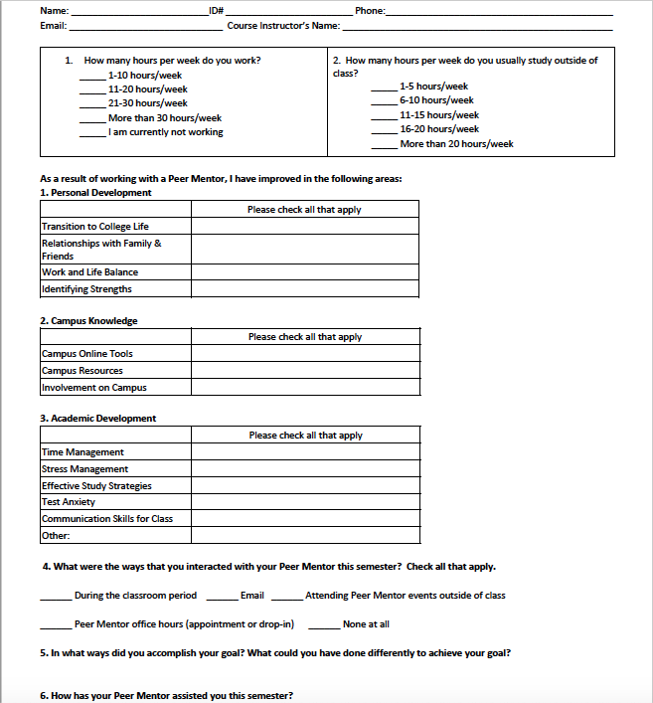

Figure 1 Mentoring Intro and Outro Form (Front Page)

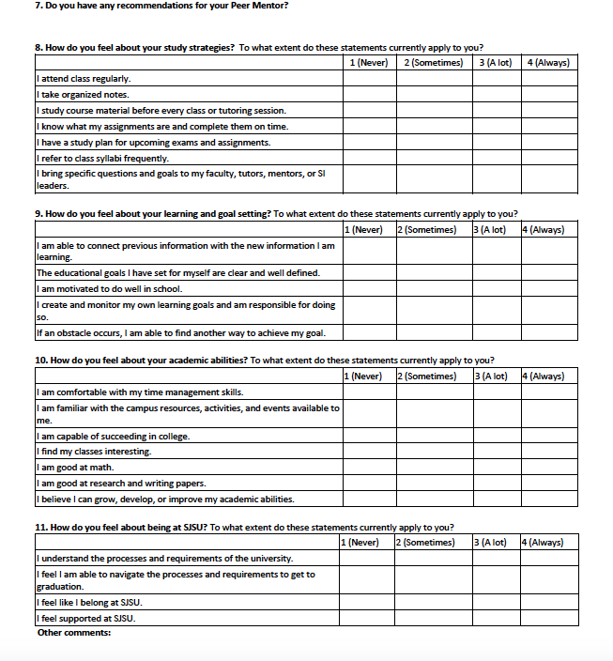

Figure 2 Mentoring Intro and Outro Form (Back Page)

The data from the intro and outro surveys for Fall 2018 semester were requested from the Peer Connections management. The data was requested to be able to determine if working with a mentor was beneficial to the students. The researchers recorded the information from these surveys in an excel worksheet.

### Data for Supplemental Instruction Sessions

The researchers scheduled a meeting with the SI coordinator. Prior to meeting the SI coordinator, the researchers developed a list of requirements so as to be able to find any patterns how exactly the current scheduling of the sessions is being done, determine the number of students taking part in these sessions, whether or not these scheduling helping students with their academic requirement, and whether there is any need of optimization in scheduling sessions. The requirements requested included details about the following:

* SI leader first and last name
* Course name
* SI session schedule day and time
* Course academic schedule; day and time
* Classroom allocated for SI Session
* The number of students attended the session

The data provided by the management consisted of an excel workbook which contained the following information

# RESULTS

### Tutor Mentor Usage Results

Peer Connections management provided the Tutor and Mentor usage data to the researchers in the form of Excel spreadsheets (Table 1 and 2). The spreadsheet consisted of individual sheets for tutor and mentor usage for different semesters (Spring and Fall) from 2016 until 2018. In total there were 6 sheets in the provided spreadsheet viz Tutor usage Spring 2016, 2017, and 2018. And Fall 2016, 2017, and 2018.

The tutor data (Table 1) consisted of the following columns/data fields

* Tutor’s first and last names
* Tutor’s total hours available- Total number of office hours present at Peer Connection.
* Tutor’s total scheduled hours for appointments- Total number of hours tutored.
* Number of subjects tutored
* Courses tutored (this column was not available for all the semesters)
* Tutor Usage by weeks in a semester – tutor usage is calculated by the management; dividing total scheduled hours for appointments by total hours available.
* Data also contained drop-in tutoring usage. – this data consisted of same columns/data fields as that of tutor usage data.

Table Tutor Usage Data

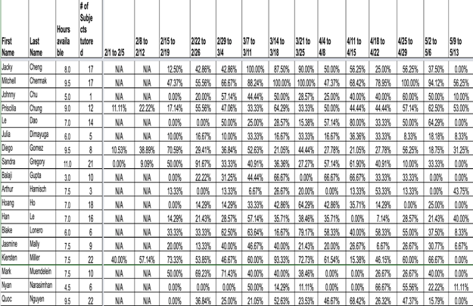

The mentor data (Table 2) consisted of the following columns/data fields

* Mentor first and last names
* Mentor’s total hours available -Total number of office hours present at Peer Connection.
* Mentors’ total scheduled hours for appointments. - Total number of hours mentored.
* Mentors Usage by weeks in a semester – Mentor usage is calculated by the management; dividing total scheduled hours for appointments by total hours available.

Table Mentor's Usage Data

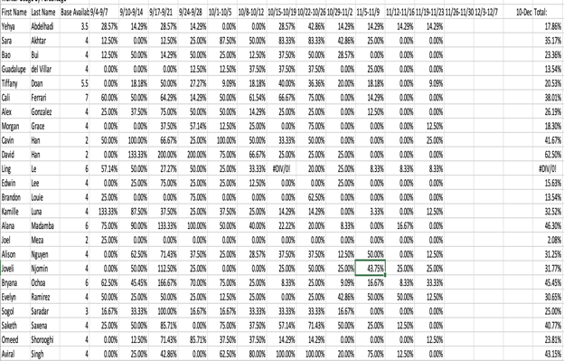

Observing the tutor’s and mentor’s usage data, considering just one row in Table 2 – Mentor’s usage data has the usage percentage of that particular mentor for all weeks in a semester. For instance, for the first mentor, the total percentage for the first week (9/4 – 9/7) is 28.57%. The researchers wanted to know how the percentage is distributed among the courses mentored. If this distribution of usage was provided, this might have helped determine number of hours mentored for all individual courses. This information could have helped see that what courses are mentored more and consider the possibilities of doing more publicity for Peer Connections in those courses which had fewer mentoring appointments.

Table 3 shows a summary of what data was requested and what was provided by Peer Connections management. It also presents what data is missing from the researcher’s perspective, and how it might impact the analysis/study.

Table 3 Comparison of Tutors and Mentors data requested, and data provided

| **Peer Connections Services** | **Data Requested** | **Data Provided** | **Missing Data** | **Comments/ Impact on study** |
| --- | --- | --- | --- | --- |
| **Tutoring** | * Number of hours scheduled for a tutor per week for an entire semester * Number of courses tutored * Number of hours tutored for individual courses from the list of courses tutored | * first and last name total hours available * Number of courses tutored * Courses tutored (this column not available for all the semesters) total scheduled hours for appointments * Aggregate usage of all courses mentored by weeks in a semester * Drop-In tutoring available hours * Drop-In tutoring scheduled hours for appointment | * Number of hours tutored for individual courses from the list of courses tutored. | * Not able to determine how many hours were invested in a particular course which contributed to the aggregate tutor usage. * In Drop-In tutoring, if the tutor is not present, student's information is not recorded. This leads to a missed appointment. |

(Table 3 continued on the next page)

|  |  |  |  |  |
| --- | --- | --- | --- | --- |
| **Mentoring** | * Number of hours scheduled for a tutor per week for an entire semester * Number of courses mentored * Number of hours mentored for individual courses from the list of courses mentored * Mentoring Intro form survey responses * Mentoring Outro form survey responses | * first and last name * total hours available total scheduled hours for appointments * Aggregate usage of all courses mentored by weeks in a semester * Mentoring Intro form survey responses * Mentoring Outro form survey responses | * Number of hours mentored for individual courses from the list of courses mentored. | * The number of hours mentored for individual courses from the list of courses tutored was missing. * Due to this the researchers were not able to determine how many hours were invested in a particular course which contributed to the aggregate mentor usage. |

### Supplemental Instruction Sessions

Peer Connections management provided the SI session data to the researchers in the form of Excel spreadsheets (Table 4). The following information was included in the spreadsheet

1. SI leaders’ schedules
2. SI leader assigned courses
3. SI leader office hours
4. SI session location

Table 4 Comparison of SI Data Requested and Data Provided

|  |  |  |  |  |
| --- | --- | --- | --- | --- |
| **Peer Connections Services** | **Data Requested** | **Data Provided** | **Missing Data** | **Comments/ Impact on study** |
| **Supplemental Instructions (SI)** | * SI Leader first and last name * Course name * SI session schedule - day and time * Course academic schedule - day and time * Classroom allocated for SI session * Number of students attended the session | * Course name * SI Leader first and last name * Course academic schedule - day and time * Classroom allocated for SI session | * Course academic schedule - day and time * Number of students attended the session | * The data requested was not provided, as the SI management was unavailable. * The researchers were unable to find a pattern of how scheduling is done. |

Tables 3 and 4 depicts the information that was requested and the information that was received from Peer Connections. As a result, the researchers were unable to proceed with the initial objectives of this study. Given the data that was made available to the researchers, the objectives had to be revised as follows:

1. Create data visualizations and extract metrics key performance indicators (KPIs) to evaluate and maximize mentor/tutor usage
2. To evaluate the result of working with a mentor.
3. Create a framework to track and record the missed appointments.

## Data Cleaning

On reviewing the data in the spreadsheet, the researchers observed that

1. The data columns names were the range of dates of a particular week in a semester. It was changed to “Week#” i.e. Week 1, Week 2, etc.
2. The N/A values in the data were replaced with zero.
3. In intro and outro survey responses, data fields such as student ID, student phone number, and student timestamp of submission of the from were dropped, as they were not adding value to the analysis.
4. Not all students completed both the intro and outro surveys. The researchers decided to include the responses that completed both the intro and outro surveys. The data is from Fall 2018 semester in Table 5.

Table 5 Data collected from Intro and Outro forms data format

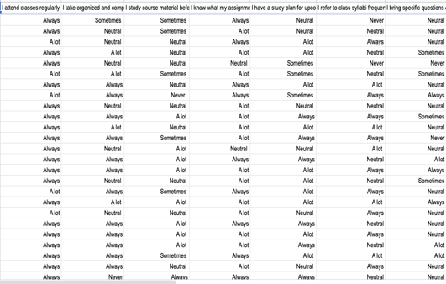

One of the objectives for this study was to visualize the cleaned tutor and mentor usage data and extract key performance indicators (KPIs) to evaluate and maximize tutor and mentor usage. In order to achieve this objective, the analysis task is divided into 3 sub tasks which are

1. Aggregating the data to get an overview of tutor and mentor usage by weeks per semester
2. Visualizing the aggregated data for tutor and mentor usage.
3. Extracting KPIs

#### Aggregating the data to get an overview of tutor and mentor usage by weeks per semester:

The tutor and mentor usage data provided by Peer Connections management was used to create summary tables. The researchers used Excel (Microsoft, n.d.) to create these summary tables presented in Table 4 and 5.

Table 6 Aggregated Tutor Usage

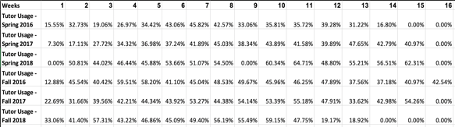

Table 7 Aggregated Mentor Usage

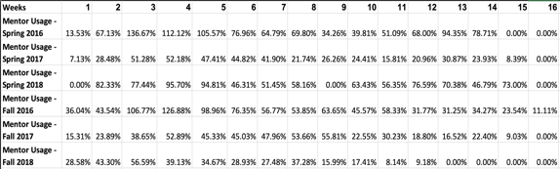

#### Tables 6 and 7 provide information about aggregate usage of all the tutors and mentors for each week for all semesters respectively. The aggregate tables were created by taking an average mean of all the tutor’s and mentor’s usage for each week (1-16) from Spring 2016 until Spring 2018 and Fall 2016 until Fall 2018.

#### Visualizing the aggregated data for tutor and mentor usage.

Line plots were created using to understand the tutor and mentor usage by weeks for all semesters (Spring and Fall). These plots are presented below.

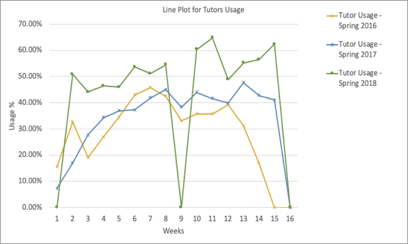

Figure 3 Line Plot for Tutor Usage from Spring 2016 - 2018

Spring semester tutor usage (Figure 3):

1. tutor usage increased from Spring 2016 till Spring 2018
2. In Spring 2018, the usage generally increased from week 3 to week 11. Usage in week 9 was 0% due to spring break. The increase in usage may be attributed to midterm exams that are typically scheduled either before or after spring break.
3. Usage decreases after spring break and peaks again in Week 15. The increase in tutor usage for Spring 2016 and 2018 from Week 13 to 15 is attributed to finals weeks which are scheduled in Week 14 and Week 15 for the semesters mentioned.
4. The tutor usage has increased in Spring 2018 in comparison to Spring 2016 and 2017 semesters.

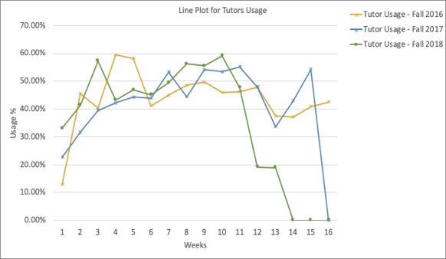

Figure 4 Line Plot for Usage from Fall 2016 - Fall 2018

Fall semester tutor usage (Figure 4):

1. In Fall 2016, the tutor usage increased from week 1 till week 4 and then decreased till week 6. There was an increase during week 8 and week 9 which might be attributed to mid-terms. The usage then decreased till week 14 and then increased during week 15 and week 16 which might be attributed to the finals.
2. In Fall 2017, the tutor usage increased from week 1 till week 7. There was a decrease during the week 8 which might be attributed to mid-terms.
3. In Fall 2018, Usage dropped from week 10 till the next 4 weeks. So, the tutoring services were not used by the students during finals weeks.

Similarly, figure 5 and 6) shows the overview average mean of Mentor usage for all the weeks (1-16) from Spring 2016 until Spring 2018 and Fall 2016 until Fall 2018.

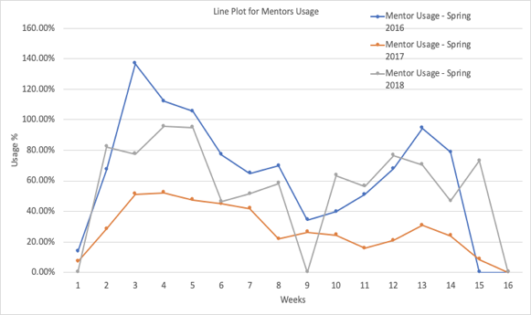

Figure 5 Line Plot for Mentor Usage from Spring 2016 - 2018

Spring semester mentor usage (Figure 5)

1. In Spring 2016, the usage increased from week 1 till week 3 and then decreased till week 7. It slightly increased during the week 8 which can be attributed to the mid-terms. It then decreased during the week 9. The usage then increased till week 13, which can be attributed to the finals and decreased to 0% by week 15.
2. In Spring 2017, the usage increased from week 1 till week 3 and then decreased till week 8. It increased slightly during week 9 and decreased till week 11. Usage increased till week 13, which could be due to the finals and decreased to 0% by week 16.
3. In Spring 2018, the usage increased from week 1 till week 5. Week 9 has 0% usage which can be attributed spring break.
4. The mentor usage for Spring 2016 has a higher usage compared to Spring 2017 and 2018.

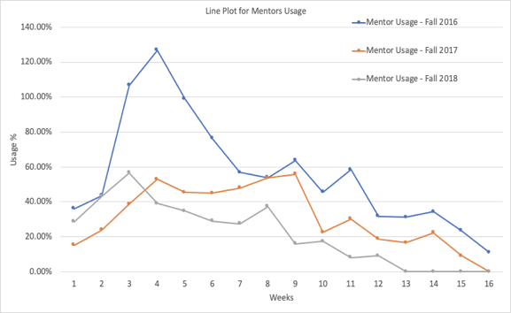

Figure 6 Line Plot for Tutor Usage from Fall 2016 - Fall 2018

Fall semester mentor usage (Figure 6)

1. For all the three semesters, there is an increasing pattern for the first three weeks and then a gradual decrease for the rest of the weeks.
2. The Fall 2016 semester has more usage compared to other semester; Fall 2017 and 2018.

#### Extracting KPIs

Considering the above analysis for Objective 1 and tutor’s/mentor’s weekly usage calculation done by the management includes metrics like

* Total available hours.
* Total Scheduled hours for appointments.

These metrics provides number of hours which are actually used in calculating the usage of a tutor/mentor. Using these two metrics, the performance of this tutoring and mentoring program can be evaluated i.e. whether or not these services are being used efficiently and to its full potential. Therefore, these can be considered as the key performance indicator (KPIs) which might help in scheduling the hours accordingly.

### Evaluation of working with a mentor

The second objective was to evaluate the result of working with a mentor. This objective can be achieved with these two methods below

1. Visualizing the responses for the questions asked in the intro and outro forms.
2. To compare the visualizations for intro and outro responses.

#### Visualizing the responses for the questions asked in the intro and outro forms:

That questions that were asked in the intro and the outro forms are as follows

1. I attend class regularly. (Figure 7)
2. I take organized notes. (Figure 8)
3. I study course material before every class or tutoring session. (Figure 9)
4. I know what my assignments are and complete them on time. (Figure 10)
5. I have a study plan for upcoming exams and assignments. (Figure 11)
6. I refer to class syllabi frequently. (Figure 12)
7. I bring specific questions and goals to my faculty, tutors, mentors, or SI leaders. (Figure 13)
8. I am able to connect previous information with the new information I am learning. (Figure 14)
9. I create and monitor my own learning goals and am responsible for doing so. (Figure 15)
10. If an obstacle occurs, I am able to find another way to achieve my goal. (Figure 16)
11. I am comfortable with my time management skills. (Figure 17)
12. I am familiar with the campus resources, activities, and events available to me. (Figure 18)

Each question is answered for both intro and outro forms on four levels; Never, Sometimes, A lot, and Always. The result of a student working with a mentor can be evaluated either of the two steps mentioned below

* Observing if the number of responses of “Never” and “Sometimes” from intro form have decreased in the outro form responses.

OR

* Observing if the number of responses of “A lot” and “Always” from intro form have increased in the outro form responses.

These questions are considered are significant in evaluating the result of working with a mentor, as discussed with the Assistant Director of the Mentoring Program. These visualizations are done using Tableau (Tableau, n.d.) software and main results are provided below

#### To compare the visualizations for intro and outro responses.



Figure 7 Response Comparison for Question 1

Figure 7:

1. In intro, it can be observed that 90.28% of all the students attend classes regularly.
2. In outro, students who attended classes regularly decreased to 57.71%.
3. In the outro responses, 2.29% students said that they never attended the classes, however, the same students said they always attended classes regularly.
4. Although the percentage for students never attending and sometimes attending classes increased in the outro responses, Majority of the students are still attending classes regularly.





Figure 8 Response Comparison for Question 2

Figure 8:

1. In intro, it can be observed that 32.20% of all the students always took organized notes.
2. In outro, 41.24% students always took organized notes and 2.26% never did.
3. In the outro responses, 2.26% students who never took organized notes ranked themselves in the intro forms for taking organized notes sometimes.
4. Although the percentage for students never taking notes increased by 2.26%, students who took organized notes increased by 9.04% in the outro responses.



Figure 9 Response Comparison for Question 3

Figure 9:

1. In intro, it can be observed that 6.86% of all the students study course material before every class or tutoring sessions.
2. In outro, students who studied course material before every class or tutoring sessions increased to 17.71%.
3. In the outro responses, 9.71% students said that they never studied course material before every class or tutoring sessions. However, the some of the students from these responses ranked themselves in the intro form, that they sometimes studied course material before every class or tutoring sessions.
4. Although the percentage for students never studying course material increased by 4%(approx.) in the outro responses, there is 11% (approx.) increase in students studying the course material before every class.





Figure 10 Response Comparison for Question 3

Figure 10:

1. In intro, it can be observed that 48.59% of all the students knew what their assignments were and completed them on time.
2. In outro, 58.19% students knew what their assignments were and completed them on time, and 2.26% never knew about their assignments.
3. In the outro responses, 2.26% students said that knew what their assignments were and completed them on time. However, some of the students from these responses ranked themselves as “A lot” in the intro form.
4. Although the percentage for students never knowing what their assignments increased by 2.26% in the outro responses, there is 9.6% increase in students knowing about their assignments.



Figure 11 Response Comparison for Question 5

Figure 11:

1. In intro, it can be observed that 4.57% of all the students never had a study plan for upcoming exams and assignments.
2. In outro, students who never had a study plan for upcoming exams and assignments decreased to 2.86%.
3. The percentage of students who always had a study plan for upcoming exams and assignments increased by 16%(approx.) in the outro responses.



Figure 12 Response Comparison for Question 6

Figure 12:

1. In intro, it can be observed that 22.86% of all the students always referred to the syllabi and 2.29% never did.
2. In outro, 38.86% students always referred to syllabi while 4% students never did.
3. In the outro responses, 4% students responded that they never referred the syllabi frequently. However, these students had a mix of responses other than “never” in the intro form.
4. Although the percentage for students never referring syllabi increased by 2%(approx.) in the outro responses, there is 16% increase in students referring to the class syllabi.



Figure 13 Response Comparison for Question 7

Figure 13:

1. In intro, it can be observed that 12% of all the students always brought specific questions and goals to the faculty and 16.57% never did.
2. In outro, 16.57% students always students always brought specific questions and goals to the faculty while 12% students never did.
3. In the outro responses, 12% students responded that they never brought specific questions and goals to the faculty. However, these students ranked themselves as “sometimes” for bringing the specific questions to the faculty in the intro form.
4. Although the percentage for students never bringing questions increased by 7.43% in the outro responses, there is 4.57% increase in students bringing question to the faculty.



Figure 14 Response Comparison for Question 8

Figure 14:

1. In intro, it can be observed that 10.29% of all the students were always able to connect previous information with new information learnings and 0.57% were not able to.
2. In outro, 28% students were always able to connect previous information with new information learnings while 2.29% students never did.
3. In the outro responses, 2.29% students responded that they never were able to connect information. However, these students ranked themselves as “sometimes” and “A lot” for the same question.
4. Although the percentage for students never being able to connect information increased by 1.72% in the outro responses, there is 17.71% increase in students who were able to connect the previous information with the new learnings.



Figure 15 Response Comparison for Question 9

Figure 15:

1. In intro, it can be observed that 35.43% of all the students always were able to create and monitor their own learning goals and 1.14% were not able to.
2. In outro, 30.86% students were able to create and monitor their own learning goals and 3.43% were not able to.
3. In the outro responses, 3.43% students responded that they never were able to create and monitor their own learning goals. However, these students ranked themselves as they were sometimes able to create and monitor their own learning goals.
4. The percentage for students who were never able create and monitor their own learning goals increased by 2.29% in the outro responses. And There is 4.57% decrease in students who were able to create and monitor their own learning goals



Figure 16 Response Comparison for Question 10

Figure 16:

1. In intro, it can be observed that 21.14% of all students find another way to achieve their goals if an obstacle occurred and 0.57% never did.
2. In outro, 32% students were able to find another way to achieve their goals if an obstacle occurred and 2.86% were not able to.
3. In the outro responses, out of 2.86% students, most of them responded that a lot of times they were able to find another way to achieve their goals if an obstacle occurred.
4. Although the percentage for students who were never able to find another way to achieve their goals increased by 2.29% in the outro responses, there is 10.86% increase in students who were able to.



Figure 17 Response Comparison for Question 11

Figure 17:

1. In intro, it can be observed that 6.86% of all students were comfortable with their time management skills and 5.14% were not comfortable.
2. In outro, 24% students were comfortable with their time management skills and 8% were not comfortable.
3. In the outro responses, out of 8% students who were never comfortable with their time management skills, most of them responded that sometimes they are comfortable managing their own time.
4. Although the percentage for students who were never comfortable increased by 2.86% in the outro responses, there is 17.14% increase in students who were comfortable.



Figure 18 Response Comparison for Question 12

Figure 18:

1. In intro, it can be observed that 8.57% of all students were familiar with the campus resources, and activities and 8% were not aware.
2. In outro, 25.71% students were familiar with the campus resources, and activities and 4.57% were not familiar.
3. The percentage for students who were familiar with the campus resources, and activities decreased by 3.43% in the outro responses and there is 17.14% increase in students who were familiar.

After comparing the visualizations above, it is seen that 9 out of 12 questions saw an increase in the number of “Always” responses in the outro forms. This could imply that working with a mentor throughout the semester could benefit a student. These are of course, subjective evaluations solicited from the student but could potentially be validated using a before and after semester GPA of the student or measured against performance of the student in non-mentored course (preferably same difficulty level) in the same semester. All these would be pseudo measures since there are numerous factors that account for student learning. It might also benefit to consider a survey which has enquires about performance in other courses in the same semester.

# Recommendations

## For Objective 1:

* Goal setting and tracking for KPIs.
* Involving academic staff for all courses tutored by classic tutors.
* Building a “Holistic Development Committee”

### Goal setting for KPIs:

Setting goals for the KPIs extracted can help track the usage more efficiently. For instance, if usage of tutor/mentor is below the threshold value set for a particular KPI (say Total Scheduled hours for appointments), the base hours can be reduced, or decisions can be made on hiring new staff.

### Involving academic staff for all courses tutored by classic tutors:

Academic staff is involved for embedded tutoring, similarly the academic staff should be involved for classic tutoring. The involvement will be limited to, them being aware of the Peer Connections department and the services/resources provided. It can also help with increase in number of classroom announcements made about Peer Connections in each semester.

### Building a “Holistic Development Program”:

The primary objective of this committee will be focusing on development of a student holistically. This committee will involve people from all the programs under peer connections i.e. tutor program, mentor program, Supplemental instructions program, strength coaching and workshops.

Enrolling students in this program will help Peer Connections know more about the students and help evaluate where exactly they need more help. They can be advised which program is needed to be focused more and what other programs can be beneficial to the students.

## For Objective 2:

From the Intro and the outro surveys, it can be inferred that working with a mentor did help the students. Question that arises is, are students implementing skills learnt from mentor just at school or are they also implementing these skills outside of school space as well. This will be easier to answer and analyze, if Peer Connections could collect data by sending out emails to students at the end of each semester by asking them to fill in a survey consisting of questions that will help determine if the students are making use of the skills learnt from mentors out of school space on a daily basis. This will provide a whole new perspective to see the success of mentoring program at Peer Connections.

## For Objective 3:

To achieve objective 3, creating a google form with questions asking basic information about the student and what does the student needs help with i.e. tutoring or mentoring. This is will help with getting the student on record for the first time.

If the student chooses one of the above programs, an email will be sent to the student about the chosen program which will consist of a detailed information about that program i.e. what is tutoring program, how to make an appointment, time availabilities etc. This will help keep a track of students and check for missed appointments if the student has not made an appointment after registering for Peer Connections for the first time. Moreover, follow ups can be made to the students on a weekly or biweekly basis. Figure 19 illustrates the process flow.

Student walks in Peer Connections

Email sent to the student with information like

* How to book a tutoring appointment.

No Appointment booked

* A google form is administered to the student at welcome desk
* Form Asking for basic information like Name, Student ID. Etc.
* Here for Tutoring? Mentoring? SI?

Tutoring

OR

Mentoring

Follow up with the student

No Appointment booked

Email sent to the student with information like

* How to book a mentoring appointment.

# 

# Concluding Remarks

Aggregating and visualizing the tutor’s and mentor’s usage data followed by extracting KPIs might be helpful to achieve the objective of fully utilizing tutor and mentors. Comparing the mentoring intro and outro responses, there were 9 out of 12 questions that showed students were benefited by working with a mentor. Creating a framework by building a process map might track and record any missed appointments. Peer Connections could also consider some of the recommendations mentioned in the report to make this program even more efficient and help the students reach their full potential.

# References

Microsoft. (n.d.). *Microsoft Excel*. Retrieved from https://office.live.com/start/Excel.aspx.

San Jose State University. (2019, May 10). *Peer Connections SJSU*. Retrieved from Welcome to Peer Conections: http://peerconnections.sjsu.edu/

Tableau. (n.d.). *Tableau*. Retrieved from https://www.tableau.com/